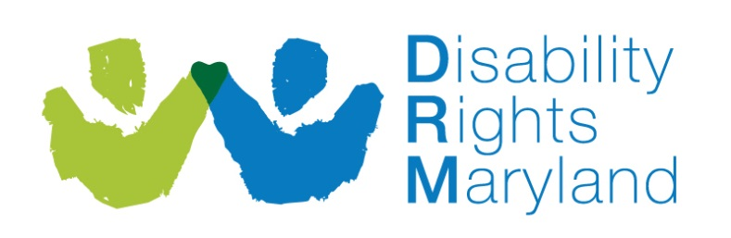
Disability Rights Maryland
Statement of Advocacy Services
Public Input Questionnaire

DRM wants your ideas on how to use our resources most effectively. Our limited funding does not allow us to address all of the barriers and problems that people with disabilities face. Please help us identifying the most important ones by reviewing DRM’s proposed priorities and by completing this survey. DRM will use the information in developing its advocacy priorities.
If you need help filing out this form or need it in an alternative format, please contact our office at (410) 727-6352; (800) 233-7201; or TTY (410) 727-6387
- Are you a
  - Person with a disability
  - Family member of a person with a disability
  - Service provider
  - Professional (please specify):_____________________________
  - Other (please specify):__________________________________

- Do you agree with DRM’s Advocacy Services Plan? (circle or highlight one)

Strongly Agree Agree Somewhat Agree Disagree Not Sure

- What do you like about DRM’s Statement of Advocacy Services?

- What do you dislike about DRM’s Statement of Advocacy Services?

- What other issues would you like to see DRM work on?

- Please describe any ways DRM could improve its services and otherwise impact the lives of persons with disabilities.

OPTIONAL:
Name:______________________________________________________:
Address:
___________________________________________________________
____________________________________________________________
County:______________________________________________________
Phone: ______________________________________________________
Email:_______________________________________________________

Please return this completed form to DRM by mail, fax or email. If you would rather tell us your thoughts rather than writing them down, please call us at (410) 727-6352 or (800) 233-7201.
Mail to:
Disability Rights Maryland
1500 Union Avenue
Suite 2000
Baltimore, MD 21211
Fax: (410) 727-6389
Email: Feedback@DisabilityRightsMD.org

