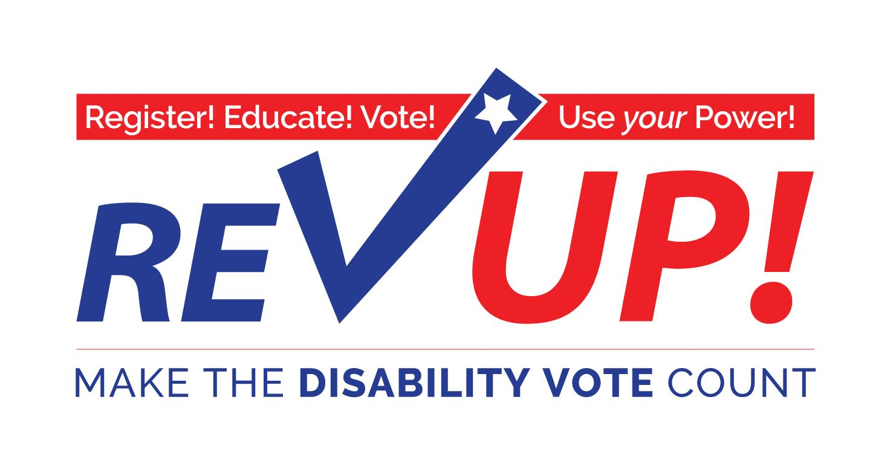
MARYLAND TOOLKIT
Presented by
Independence Now
Disability Rights Maryland

Special thanks to The Texas Disability Project for creating the initial Toolkit

The American Association of People with Disabilities
www.aapd.com/REVUP
Dear Disability Rights Advocates:
In 2016, there were 62.7 million eligible voters who either have a disability or have a household member with a disability, more than one-fourth (25%) of the total electorate (Doug Kruse & Lisa Schur, Rutgers University).
However, in the 2016 election:
- Only 16 million people with disabilities voted in the November 2016 elections (Lisa Schur and Douglas Kruse, Rutgers University).
- The voter turnout rate of people with disabilities was 6 percentage points lower than that of people without disabilities during the 2016 election (Lisa Schur and Douglas Kruse, Rutgers University).
- If people with disabilities voted at the same rate as people without disabilities who have the same demographic characteristics, there would be about 2.2 million more voters. (Lisa Schur and Douglas Kruse, Rutgers University)

The November 6th election will be one of the most important elections.
The disability community—people with disabilities, family members, attendants, providers, professionals, advocates and supporters—has a major stake in the outcome of this election.
The Disability Vote can make a difference on issues such as:
- Adequate funding and coverage for Medicaid acute and long term services and supports.
- Waiting lists for home and community services.
- Integrated employment at no less than minimum wage.
- Accessible, affordable, integrated housing.
- Any many more issues!
We need your help to register voters, help voters understand the voting process, and get voters to the polls and overcome any barriers to exercising the right to vote.
Use this toolkit to:

- Register! Educate! Vote!
- Use your Power!

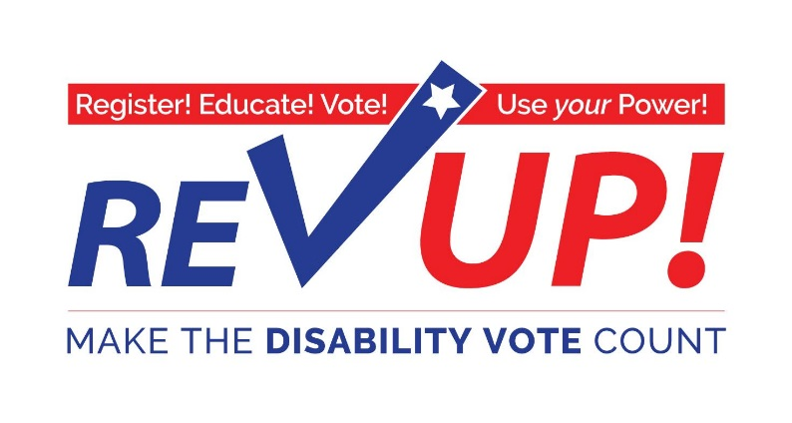
Marylanders with disabilities CAN influence the outcome
of the General Election in November

‘More than any time in memory:
- Elected leaders and political candidates are recognizing the 57 MILLION Americans with disabilities—from birth to advanced age—as a powerful, important constituency
- Issues important to people with disabilities must be part of the platform for any candidate running for public office.

Join thousands of Americans with disabilities in this important and historic effort!
Don’t Mourn…Organize, Register, and VOTE!
Onward to November 6, 2018! Make the DISABILITY VOTE Count!
For more information:
Disability Rights Maryland
www.DisabilityRightsMD.org
(410) 727-6352, ext. 2515

Independence Now
www.innow.org
(240) 898-2183

How to Join the Maryland REV UP 2018 Campaign
and
Increase the Power of the Disability Vote:
REV UP 2018 encourages individuals to take these steps:

Step 1 Review the Maryland Rev Up Toolkit. The Toolkit includes information and resources to help people with disabilities and supporters register and vote. For more information about REV UP 2018 go to www.aapd.com/REVUP
Step 2: Make sure YOU are registered to vote!
Step 3: Distribute information and registration forms to your friends for them to complete to ensure that they are registered to vote.
Step 4: Schedule a voter registration and training presentation with Disability Rights Maryland (DRM). Contact Tracy Wright, Voting Advocate at DRM, by phone at 443-690-2603 or by email at tracyw@DisabilityRightsMD.org
Step 5: Let people know about the Voter Hotline at Disability Rights Maryland and report a voting concern by calling 443-692-2492 or emailing at voting@DisabilityRightsMD.org
Step 6: Use the Polling Place Survey (at the end of this Toolkit) when you vote to help us collect information about the accessibility of polling places nationally.

Important pointers for talking to people about voting:
DO: | DO NOT:
- Encourage family, friends and others to register to vote and, if eligible, to request a ballot by mail.  - Explain and emphasize the importance of the disability vote and the rights of individuals with disabilities to vote.  - Encourage friends, colleagues, and family members to request a REV UP 2018 Toolkit from www.aapd.com/REVUP | - Recommend, endorse, or encourage support for one candidate or party over another.  - Tell the people you’re registering which party to register under or who to vote for.  - Coordinate activities with a candidate or campaign or political party  - Target your registration efforts toward any particular ideological group, party, or issue.
Guide for talking to others about voter registration and REV UP 2018 :
Ask the question, “Are you registered to vote?”
If the answer is NO: | If the answer is YES:
Would you like register? It’s easy!  - Provide them with the registration form.  - Forms are available for download from the Maryland State Board of Elections website at http://www.elections.maryland.gov/  Would you like assistance to complete the registration form?  - You may assist them in completing the registration form.  You need to mail the registration form to the County Board of Elections.  - The address for the County Board of Elections Office is on the voter registration form or available on the State Board of Elections website  - You may assist them in mailing in the form.  Voter Registration Forms must be sent in to the County Board of Elections by October 16, 2018.  Remind them that General Election day is November 6, 2018. | Do you need to apply by absentee ballot?  It’s easy!  - Provide them with the information about voting by absentee ballot.  - Applications can be downloaded from the State Board of Elections website at http://www.elections.maryland.gov/  Would you like assistance to complete the application for an absentee ballot?  - You may assist them in completing the absentee ballot application.  The applicant needs to mail the application to the County Board of Elections.  Absentee ballots must be submitted to the County Board of Elections by:  - Tuesday, October 30, 2018, if the voter want to receive your ballot by mail or fax  - Friday, November 2, 2018, if the voters wants to download the ballot from the State's website  Ballots must be mailed or delivered to the County Board of Elections Office by November 6, 2018.

2018 Voting Dates to Remember

NOVEMBER GENERAL ELECTION
- October 16, 2018: Last day to register to vote in the General Election
- Early voting: Thursday, October 25, 2018 through Thursday, November 1, 2018 from 10 am until 8 pm.
- Your request for an Absentee Ballot (vote by mail) must be received by:
Tuesday, October 30, 2018, if you want to receive your ballot by mail or fax
Friday, November 2, 2018, if you want to download your ballot from the State's website
- If you mail your Absentee Ballot, the envelope must be postmarked on or before Election Day and received by your local board of elections by November 18, 2016.
- November 6: Election Day!

Same Day Voter Registration during Early Voting
Voters can also register to vote during early voting. The voter must go to an early voting center in the county where he or she lives and bring a document that proves where they live. This document can be an MVA-issued license, ID card, or change of address card, or paycheck, bank statement, utility bill, or other government document with the name and address of the voter.

Your Vote Matters
Information for Individuals with Disabilities

You have the right to:
- Vote by yourself and make your own choices.
- Get help from a person of your choice or an election worker.
- Use a physically accessible polling place and an accessible voting machine.
- Vote if you have a guardian, unless a court determines you cannot.

Help America Vote Act (HAVA)
The goal of the Help America Vote Act (HAVA), passed by Congress in 2002, is to make the voting process more inclusive and accessible so that more Americans will become registered voters and participate in elections.

Disability Rights Maryland (DRM) is the Protection & Advocacy agency designated by HAVA to help ensure accessible voting in Maryland. Specialists on staff can answer questions, respond to legal violations, and troubleshoot problems related to your voting rights. There are no costs for these services.

Disability Rights Maryland provides the following services related to voters with disabilities:
- Educates voters, election workers, and other persons involved in the voting process about the rights of people with disabilities.
- Provides information to people with disabilities about voter registration and the chance to register to vote.
- Provides advice about access to polling places on Election Day.
- Works with groups representing people with disabilities and other organizations in registering voters and surveying polling places for accessibility.
- Represents/advocates for individuals with disabilities who have complaints about the voting process.

Who can register to vote?
To register to vote, you must be:
- A U.S. citizen;
- A Maryland resident; and
- At least 16 years old*.
You cannot have been:
- Convicted of buying or selling votes;
- Under guardianship for mental disability and found by a court to be unable to communicate a desire to vote; or
- Convicted of a felony and currently serving a court-ordered sentence of imprisonment. (Effective March 10, 2016)
*You may register to vote if you are at least 16 years old but cannot vote unless you will be at least 18 years old by the next general election.
How to register to Vote?
- By mail: Request an application from your local voter registration office.
- In person: At the Motor Vehicles Administration, Public Library, Post Office, or any state agency that provides public assistance.
- Online: Use a computer and go to: https://voterservices.elections.maryland.gov/OnlineVoterRegistration/InstructionsStep1
Different ways to vote.
In addition to voting in person on Election Day, you can vote in these ways:
- By Absentee Ballot: Voters may apply for an Absentee Ballot.
To get an application for an Absentee Ballot and to check deadlines, go to: http://www.elections.state.md.us/voting/absentee.html
- Early voting: You can vote early in person at any polling place in your county. Early voting begins Thursday, October 25, 2018 through Thursday, November 1, 2018 from 10 am until 8 pm. To find an early voting center near you, go to: http://www.elections.state.md.us/voting/early_voting.html
- On Election Day on November 6, 2018 at your local polling site.

Voting Rights & Accommodations

Voting Rights
I have the right:
- To vote by myself and make my own choices.
- To get help from a person of my choice or an election worker.
- To a physically accessible polling place and the use of an accessible voting machine.
- To vote if I have a guardian, unless a court determines I cannot.

You Have a Right to Election Accommodations on Election Day
You can:
- Ask to move to the front of the line or ask for a placeholder
- Bring someone to help you
- Have headphones to hear your ballot
- Have sample ballots in alternative format
- Have accessible parking
- Have temporary ramps
- Use a communication board
- Access an accessible ballot marking machine
- Use the accessible features of the ballot marking machine

Voter Bill of Rights
As a Marylander Voter, you have the right to:

Vote in an accessible polling place. Call your local board of elections or check on-line at http://www.elections.state.md.us/voting/accessibility.html to find out if your polling site is accessible to you. The on-line polling site locator will also confirm that you are registered. To request an accessible polling site contact your local board of elections by close of voter registration.

Vote at an early voting center in the county where you live. To find an early voting center near you, go to: http://www.elections.state.md.us/voting/early_voting.html

Vote by Absentee Ballot. Any registered voter may request to vote by Absentee Ballot. To get an application and to check deadlines, go to: http://www.elections.state.md.us/voting/absentee.html

Cast a private and independent ballot.

Receive voting assistance if needed. You may ask an election judge for help, or bring any other person to help you except your employer or union official.

Mark a ballot on an accessible voting machine. You may select a large print or high contrast ballot. You may also request an audio ballot, which requires the use of headphones and a keypad. The angle of the voting machines can also be adjusted for better access.

Cast a ballot as long as you are in line when the polls close.

Vote a provisional ballot if your name does not appear on the voter registration list or there is a question about your eligibility to vote.]

It is a good idea to bring identification with you. Federal law requires that if you registered to vote by mail you must provide identification before voting for the first time in Maryland.

Voter Hotline

To report voting concerns that may be related to a disability (such as access to a polling place, voter assistance, or problems using a voting machine) contact:

Disability Rights Maryland by phone at 443-692-2492; 800-233-7201, ext. 2492; TTY 410-235-5387 or by email at voting@DisabilityRightsMD.org.

Helpful Information for Maryland Voters with Disabilities
Take this along when you vote

- To fix a problem at the polls, before you leave the polling place
- Talk to the head election judge, and if they can’t fix it, ask them to contact a county or state election official. If that doesn’t work,
- Contact Disability Rights Maryland voter hotline at 443-692-2492 or by email at voting@DisabilityRightsMD.org
- File a written complaint at your polling place.
- If you are under a guardianship…
- You still have the right to vote UNLESS your guardianship order says that the court has found that you are unable to communicate a desire to vote
- If you cannot sign your name…
- You have the right to tell the election judge who you are and tell another person to sign your name for you on the roster.
- You have the right to ask for help voting.
- Any person you choose can go with you into the voting booth – except an agent of your employer or union, or a candidate.
- It is against the law for anyone in the polling place to try to influence your vote.
- You can ask someone to mark your ballot for you.
- It is against the law for them to mark the ballot for you if you cannot communicate to them who you want to vote for.
- You have the right to take a sample ballot into the voting booth with you.
- If you make a mistake before submitting your ballot
You may go back and make corrections, follow the directions on the voting system screen or ask for help from an election judge.

A Basic Guide to Polling Place Accessibility

This is a basic guide to accessibility to assist in identifying barriers and potential solutions to ensure access to voters with disabilities. Election officials should try to select fully accessible polling places and conduct the full Department of Justice accessibility survey.

Parking and Drop-Off Areas
- If parking is provided, at least one accessible parking spot that is nearest to the accessible entrance must be provided for every 25 regular parking spaces.
- The first accessible spot should be van accessible with an access aisle at least 8ft wide.
- Accessible parking spots should be relatively level and not have loose gravel or dirt.
- If drop-off area is provided, it should be level and have an access aisle that is at least 5ft deep and 20ft long where people can access entrance (near ramp if necessary).

Solutions: Traffic cones can be used to mark accessible parking spaces and access aisles. Heavy duty mats can be used to level out uneven surfaces.

Paths of Travel
- There must be an accessible path from parking spot to entrance and voting area.
- Path must be at least 36 inches wide and free of steps or level changes more than ½ inch.
- If accessible path crosses traffic, a marked crosswalk should be used.
- Where path crosses curb, a curb cut or temporary ramp should be used.
- Ramps can’t be steep. For every 1 inch high, a ramp must be at least 12 inches long.

Preventing Obstructions for Voters Who are Blind or Have Low Vision
- People who are blind can easily run into objects that hang from above (ex. tree limbs), are open beneath (ex. staircases), or protrude from the side (ex. trophy cases).

Solution: Place a barrier within 27 inches of the floor so cane can detect the obstruction.
Entrance to Polling Place and Voting Area
- Doorways must be at least 32 inches wide.
- Threshold must not be more than ¾ inches high at door and must be beveled on each side.
- No heavy doors.
- No slick, round door handles.

Solutions: If door is too heavy to open easily, adjust door closer, disconnect operating arm, or prop door open on Election Day. If smooth round handles are on door, use temporary hardware or prop door open. If threshold is too high, use temporary threshold ramp on each side that is too high.

Voting Area
- An accessible voting machine on wheelchair accessible booth should be located along an accessible path in a location that ensures privacy.

Call the Disability Rights Maryland Voting Hotline if you have any concerns on Election Day:
- (443) 692-2492;
- (800) 233-7201, ext. 2492;
- TTY 410-235-5387 or
- Email at voting@DisabilityRightsMD.org

Also, Visit www.866ourvote.org or call 1-866-OUR-VOTE (1-866-687-8683) to report any issues or concerns related to Election Day.

Polling Place Survey
The REV UP Campaign would like to know if your polling place is accessible. Providing us information on the accessibility of your polling place may help resolve accessibility issues in the future. If you are interested in filling out this survey, please indicate the county and precinct information. You can also provide your contact information, although it is not required.
Thank you!

State: _________________________________________________________________________
County: _______________________________________________________________________
Precinct: ______________________________________________________________________
Polling place address: ___________________________________________________________
Your Name (optional): __________________________________________________________
Your Phone/Email (optional): ____________________________________________________
Parking
1. | Was there at least one accessible parking space? | Yes | No | n/a
2. | Was the accessible space marked by a visible sign (other than on the asphalt)? | Yes | No | n/a
3. | Was the accessible parking area paved? | Yes | No | n/a

Entrance
4. | Is the walkway from parking to accessible entrance free of steps? | Yes | No | n/a
5. | If there are steps or curbs, are there ramps provided? | Yes | No | n/a
6. | Was there at least one accessible entrance? | Yes | No | n/a
7. | Could you open all doors with a closed fist? | Yes | No | n/a
8. | Were all doors wide enough for a wheelchair to pass through (32 inches)? | Yes | No | n/a

Voting Area
9. Was there at least one accessible voting system provided? | Yes | No | n/a
10. Were you able to easily use the voting machine’s accessibility features? | Yes | No | n/a
If no, please explain:
______________________________________________________________________________
______________________________________________________________________________
______________________________________________________________________________
11. Were you able to cast your vote privately and independently? | Yes | No | n/a
12. If assistance or accommodations were requested, were poll workers helpful? (example: curbside voting, person of assistance, headphones) | Yes | No | n/a
If no, please explain: __________________________________________________________________________
__________________________________________________________________________
___________________________________________________________________________
- If your eligibility to vote was questioned, how did the poll worker handle the situation?
________________________________________________________________
______________________________________________________________________________
______________________________________________________________________________

- What, if any, voter education or training have you received?
_______________________________________________________________
______________________________________________________________________________
______________________________________________________________________________

- Any other comments:
_______________________________________________________________
_______________________________________________________________

Please return this survey to:
Disability Rights Maryland
Ben Jackson
1500 Union Ave, Suite 2000, Baltimore, MD 21211
BenJ@disabilityrightsmd.org

Phone: (443)-692-2492; 800-233-7201 ext 2492
TTY 410-235-5387
Fax: (410) 727-6389

