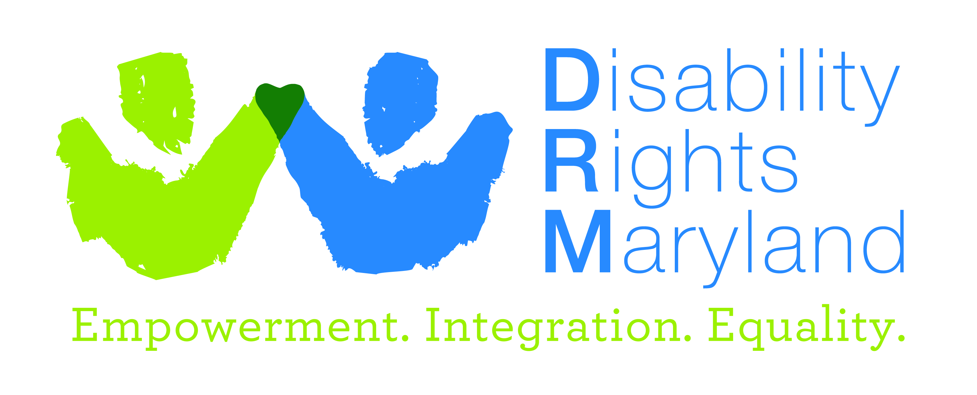

Intake Specialist
Disability Rights Maryland (DRM) is the designated Protection & Advocacy (P&A) agency in Maryland, mandated to advance the civil rights of people with disabilities. We are a 501(c)(3) nonprofit legal services organization seeking a highly capable Intake Specialist.
DRM envisions a world where people with disabilities are fully included in the workplace, neighborhoods and all aspects of community life. To move us toward this vision, we focus our advocacy toward:
- Freedom from abuse, neglect and unnecessary institutionalization;
- Access to education, health and mental health care, transportation, housing, and more;
- Legal information, counsel and technical assistance to promote self-advocacy;
- Outreach, training, and public awareness about disability rights issues;
- Individual and systemic legal representation;
- Public policy advocacy.
For more information, please visit: www.DisabilityRightsMD.org.
Intake Specialist
The Intake Specialist works under the general supervision of the Director of Operations to receive calls requesting services, information and/or referral and provide up-to-date, accurate, and relevant information, referral and advocacy assistance to callers and visitors. This position requires full-time availability between the weekday hours of 9:00 a.m. to 5:00 p.m.
Required Qualifications
The ideal candidate for this position will share our commitment to serving people with disabilities and working toward their independence and inclusion in the communities where they live. The candidate will bring a variety of experiences and attributes to DRM, including:

- Bachelor’s Degree or equivalent work experience.
- Excellent telephone, communication and social skills including the ability to handle situations patiently and tactfully.
- Ability to deal effectively with confrontational situations and stressful interactions.
- Proficiency in oral and written communication.
- Computer literacy including Windows, Word and data entry experience.
- Ability to work both independently and in collaboration with others.
- Ability to maintain confidentiality.
- Ability to comprehend and carry out complex oral and written instructions.
- Experience working with and/or sensitivity to persons with disabilities and from multi-ethnic communities.
- Ability to travel when needed. Travel is projected to be 10% or less of this position, and is almost exclusively within the state of Maryland.

Other Helpful Qualifications

1. Ability to communicate in Spanish is strongly preferred.
2. Experience providing direct customer contact via telephone in a law office or social service/non-profit environment.
3. Paid or volunteer experience working directly with DRM client populations.
4. Life experience with disability.

Application Process
Individuals with disabilities, people of color, LGBTQIA+ individuals and others who contribute to staff diversity are especially encouraged to apply. DRM is an Equal Opportunity employer.
Salary will be competitive within the legal services sector and commensurate with experience. Excellent benefits, including health care.
E-mail resume, cover letter and salary requirements to: Jobs@DisabilityRightsMD.org with “Intake Specialist” in the heading. Priority given to applications received by March 16. Position open until filled.

